Bootstrap drop-down handling

First screenshot has topic names.

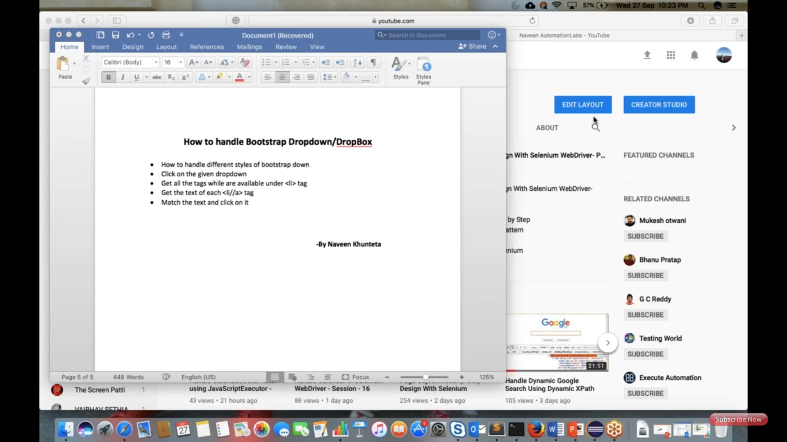

Second screenshot had URL/website of bootstrap drop-down.

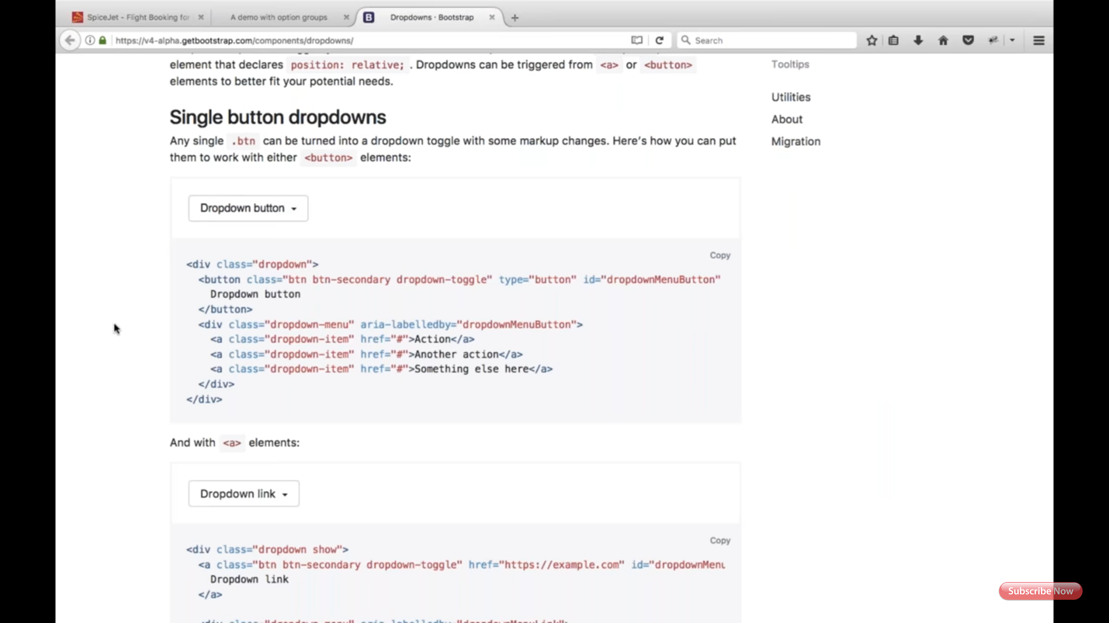

Third screenshot has URL of another bootstrap drop-down.

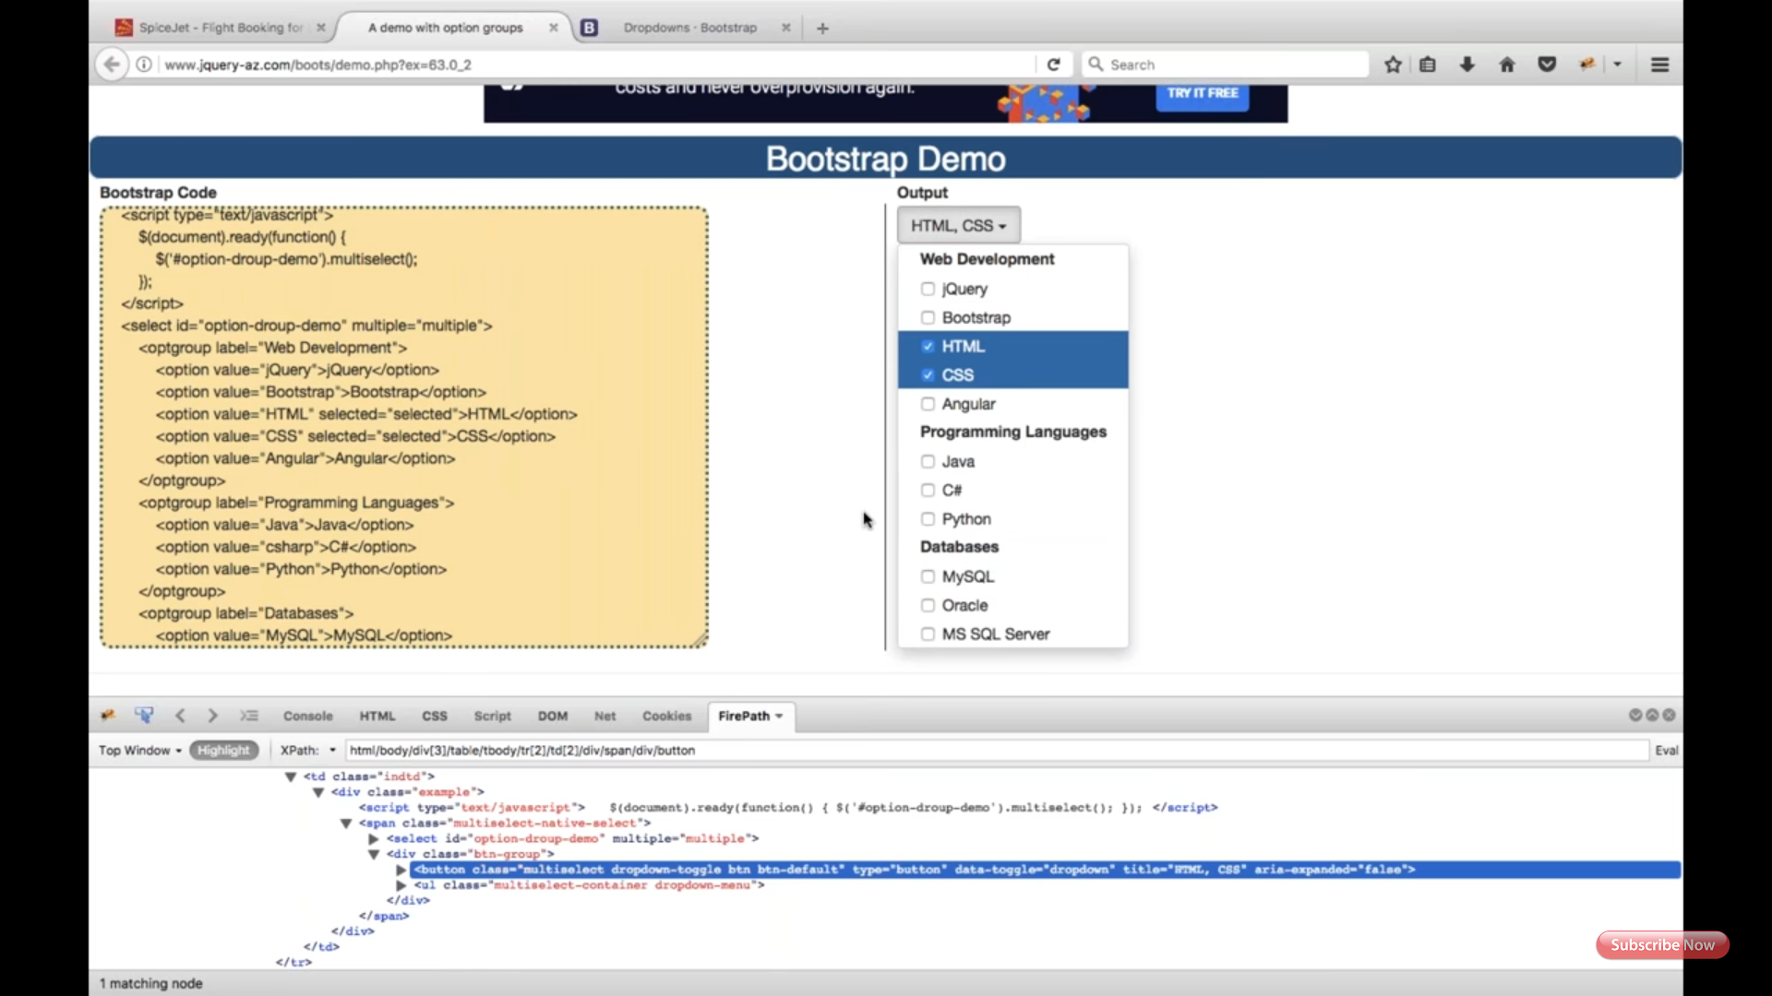

Forth screenshot explains code of selecting list item in the third screenshot URL.

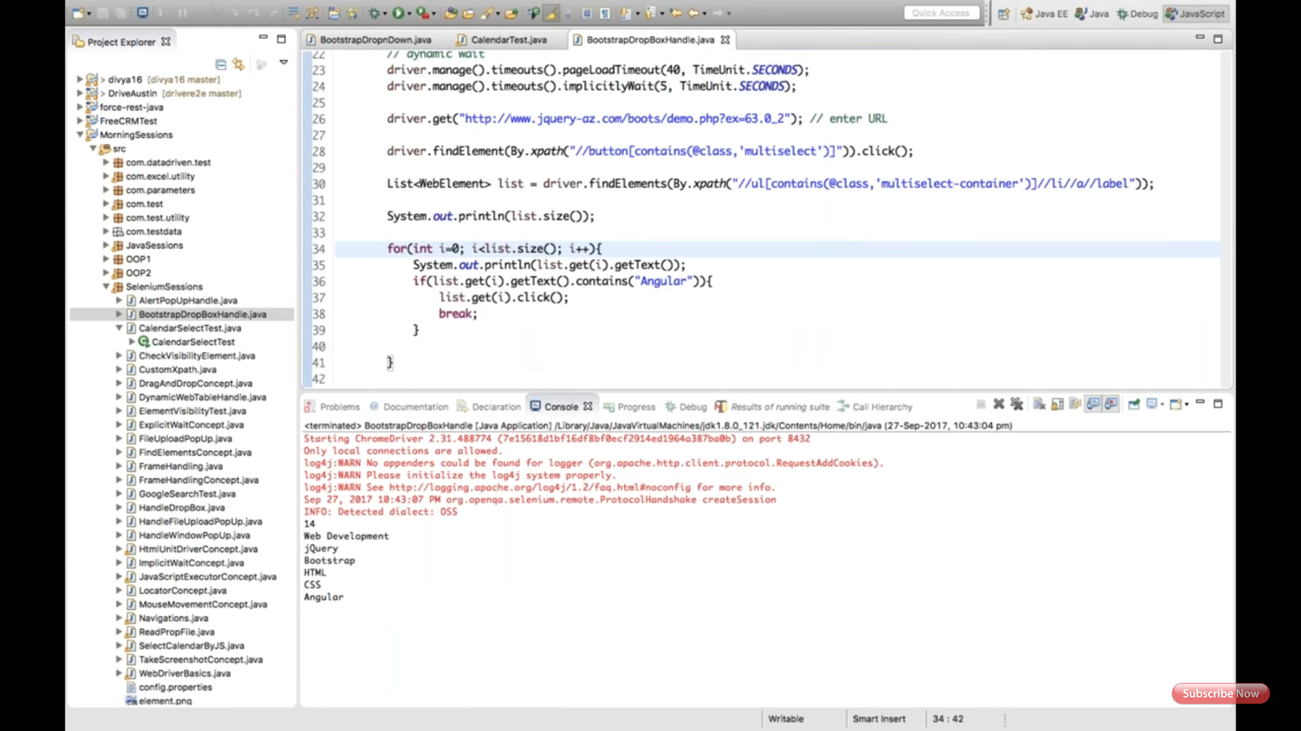

Fifth screenshot explains code of selecting all the eleminates.(use is selected method not click on the already selected items)

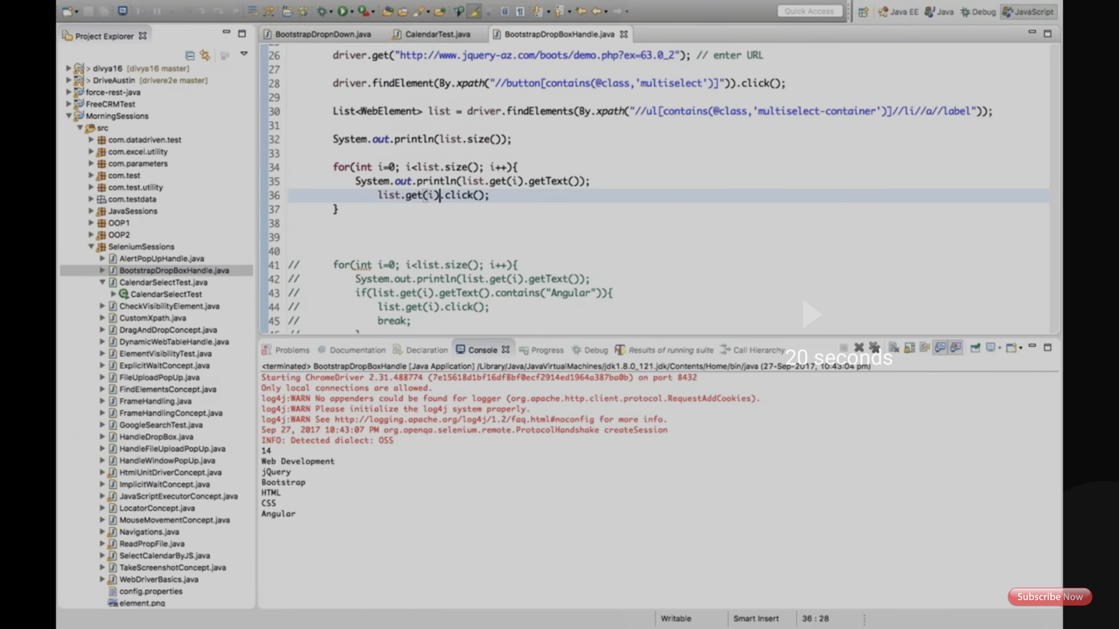

Sixth screenshot explains code of selecting list item from the second screenshot URL.

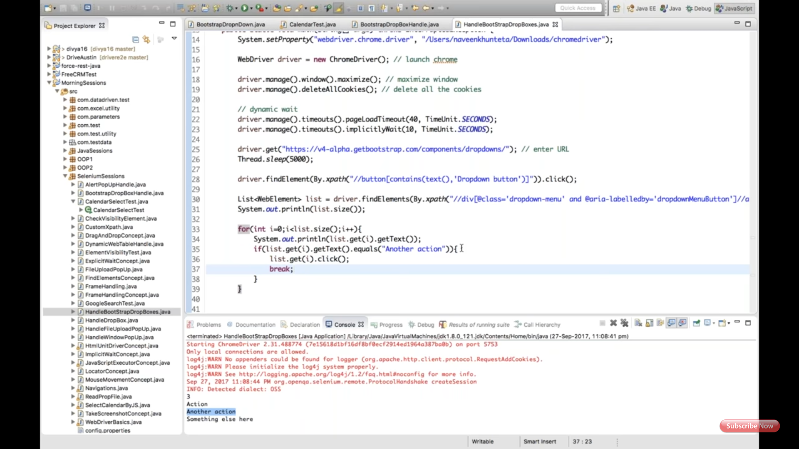

Seventh screenshot has URL of Google and it's location bootstrap drop-down.(Homework assignment)

